Author: Mohammed Kalander Shihab

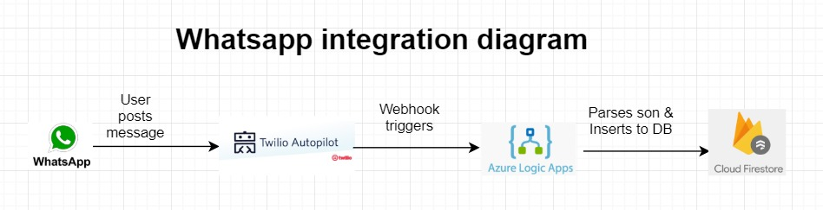

WhatsApp integration method(detailed):

A chat bot was created using Twilio autopilot. A webhook was then created for when a message is sent or received. This webhook provides lengthy JSON outputs which contain a lot of information that aren’t needed for this specific use case scenario.

Now, the problem comes in extracting only the useful data from the JSON output of the webhook.

This is where Azure Logic Apps comes to the picture.

Since my technology stack does not include python, to make the integration and deployment process more effective and in the interest of the whole team, I’ve decided to go with Azure logic apps to collect the needed information from the webhook JSON responses.

Azure logic apps let me control what’s on the final JSON output. This final output is then sent to the cloud Firestore DB via REST API.

I’ve attached the final logic app code in the repository.